# SET UP FOR API (Database first)

1. Importance Nugets

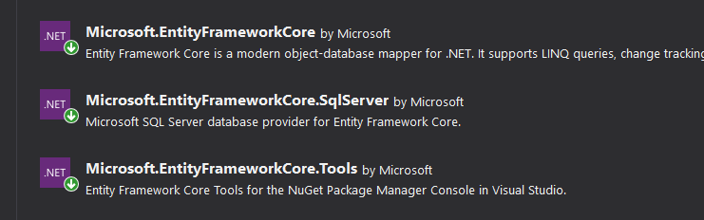

1. Create database
2. Create model by command

Scaffold-DbContext "Server=DESKTOP-GK7JKUO; Database=LaptopApiReactDB;Trusted_Connection=True;" Microsoft.EntityFrameworkCore.SqlServer -OutputDir Models

1. Add connection string to appsetting.json and dbcontext to startup.cs

"ConnectionStrings": {

"LaptopApiReactDBContext": "Server=DESKTOP-GK7JKUO; Database=LaptopApiReactDB;Trusted_Connection=True;"

}

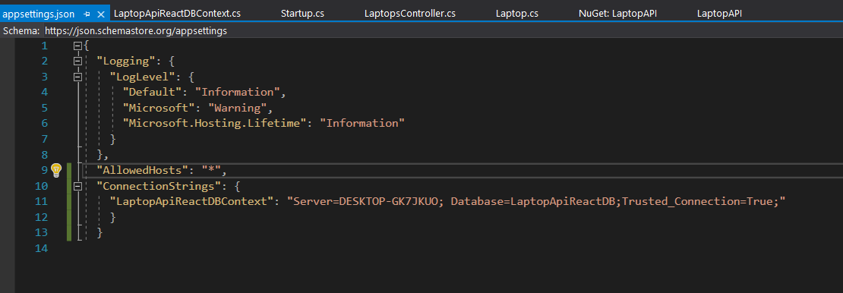

services.AddDbContext<LaptopApiReactDBContext>(options => options.UseSqlServer(Configuration.GetConnectionString("LaptopApiReactDBContext")));

